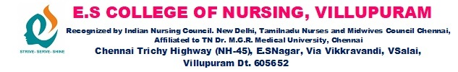

2020-2021 STUDENT NURSES ACTIVITIES

Name of the Programme: Pongal Celebration
Date: 12.01.2022
Activities: Preparing Pongal
No. of Participants: 110
Photos

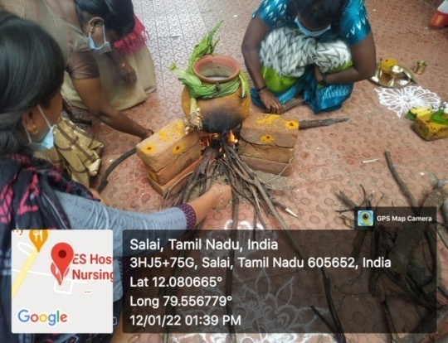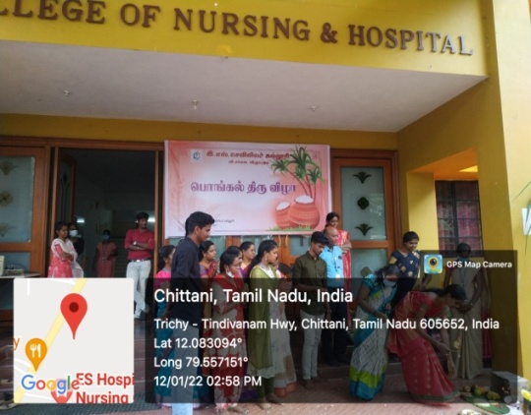

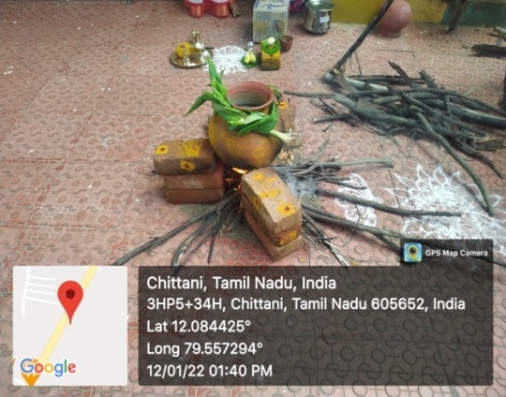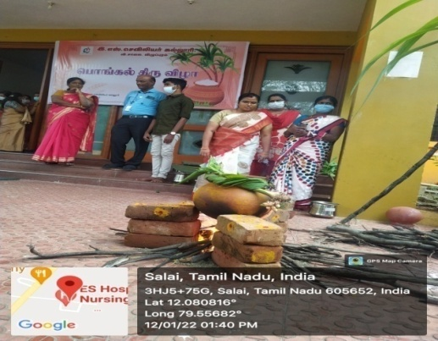

Cell/Club : SNA
Name of the Programme : Christmas Celebration
Date : 23.12.2021
Activities : Students performed dance, skit depicting the birth of Jesus followed by Entry of Santa Claus and cake Cutting.
No. of Participants : 300
Photos
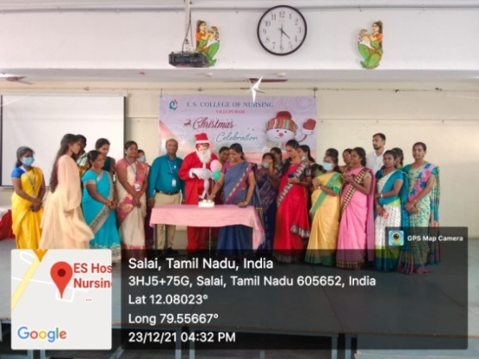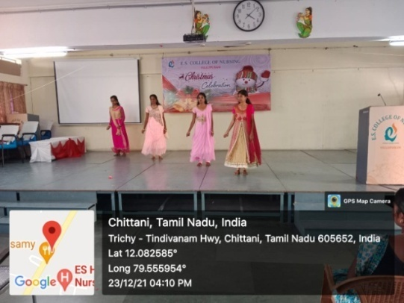

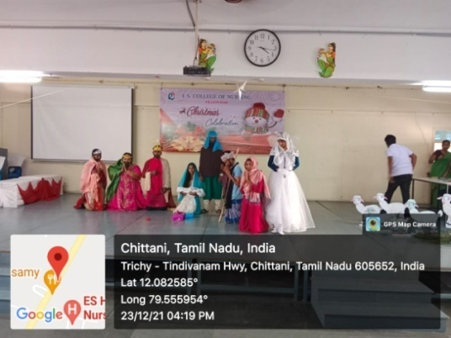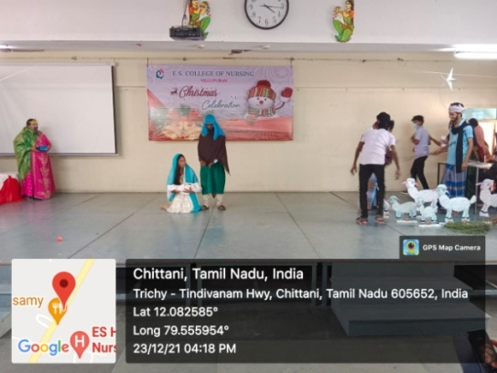

Cell/Club : SNA
Name of the programme : Universal Health Coverage Day Programme.
Theme : Leave no one’s Health behind
Date : 13.12.2021
Chief Guest : Dr.Ramkrishnan.,M.O,
Dr.Prema.,M.O(Radhapuram PHC)
Activities : 1.Orientation was given regarding ‘Leave no one’s
Health behind’ (theme of this programme)
2. Health Check up and counseling was given according to the found out problems by the student.
3. Health education was given by the students.
Place : Government High School,Radhapuram
No.of.Partcipants : 125
No.Of .Beneficiaries : 50
Outcome : Effects of Programme was assesses by feedback given by the assistant Head Master of the school.

Photos
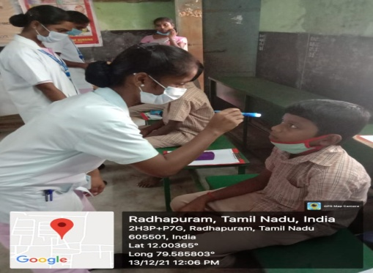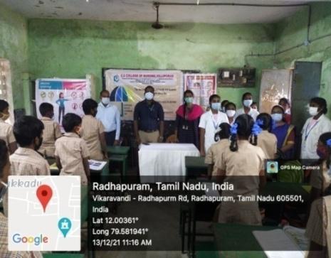

Department/Cell/Club: SNA
Name of the Programme: Karthigai Deepam
Date: 19.11.2021
Activities: Lighting traditional lamps symbolically enlighting all soul in the campus

Photo
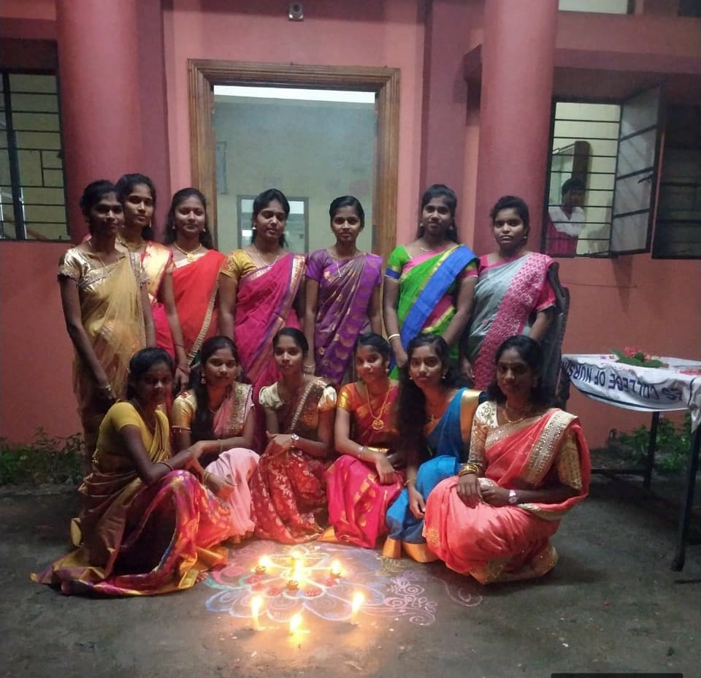

Department/Cell/Club: SNA
Name of the Programme: SARASWATHI POOJA
Date: 13.10.2021
Activities: Program Started With Prayer Song And Followed By Pooja Rituals And Distribution Of Sweets
Photo

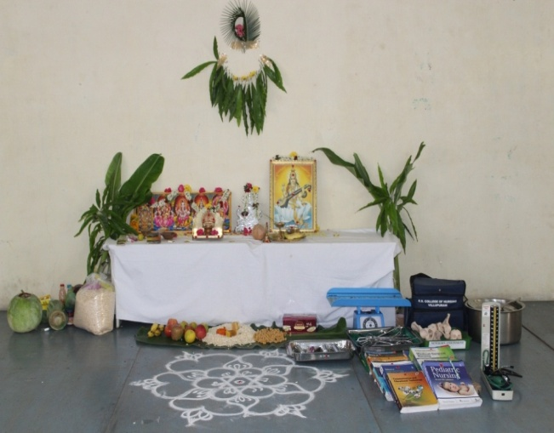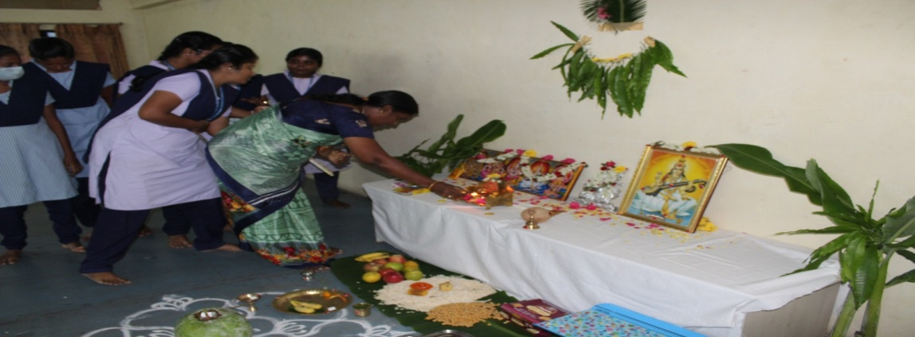

Name of the Programme: 75th Independence Day
Date: 15.08.2021
Chief Guest: Dr.Gitanjali, GVMCH Villupuram
Activities: Flag hoisting
No. of Participants: 100
Photos

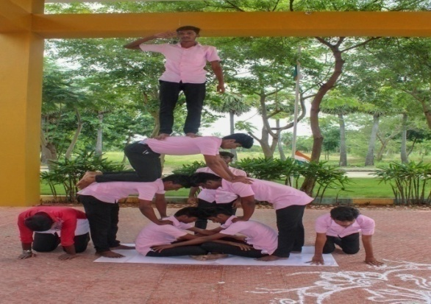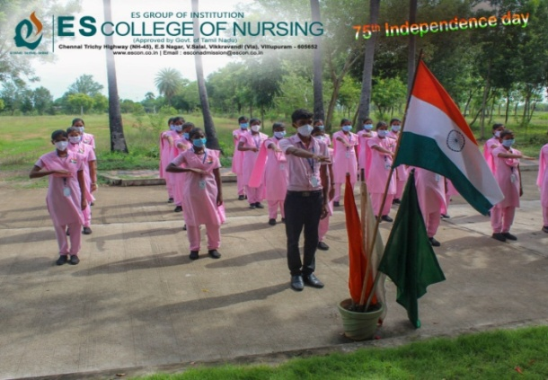
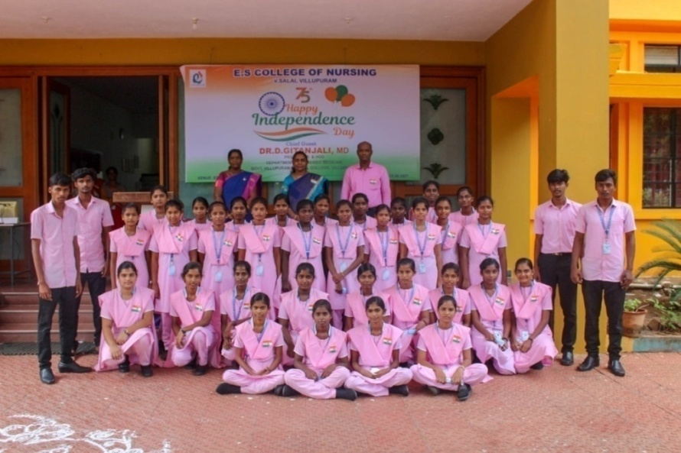

Department/Cell/Club: SNA
Name of the Programme: International Nurses Day
Theme: Nurses: A Voice to Lead-A Vision for Future Healthcare.
Date: 12.05.2021
Activities: Online competitions – e poster, reciting poetry, essay writing, quiz related to theme.
No. of Participants: 100
Outcome: Events are conducted virtually and students from various classes have been participated and prizes were distributed to the winner.
Photo

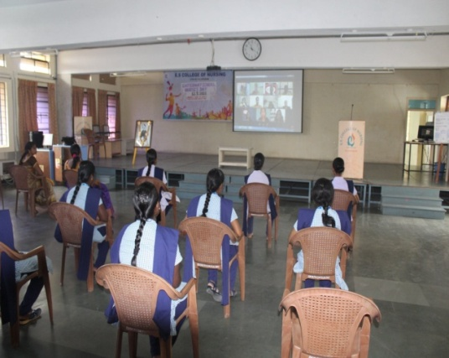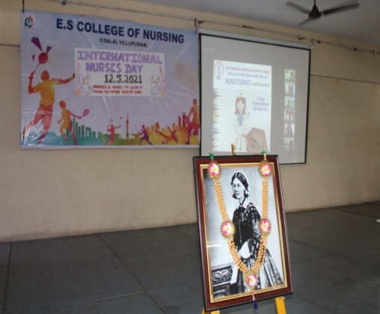

Name of the Programme: 72nd Republic Day
Date: 26.01.2021
Activities: Flag hoisting and Oath taking
No. of Participants: 100
Photos
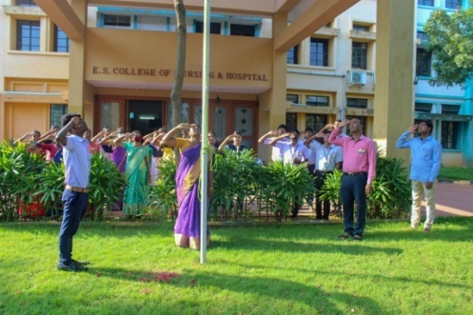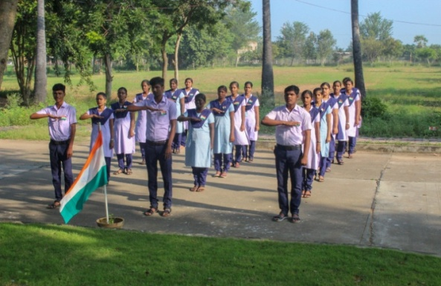
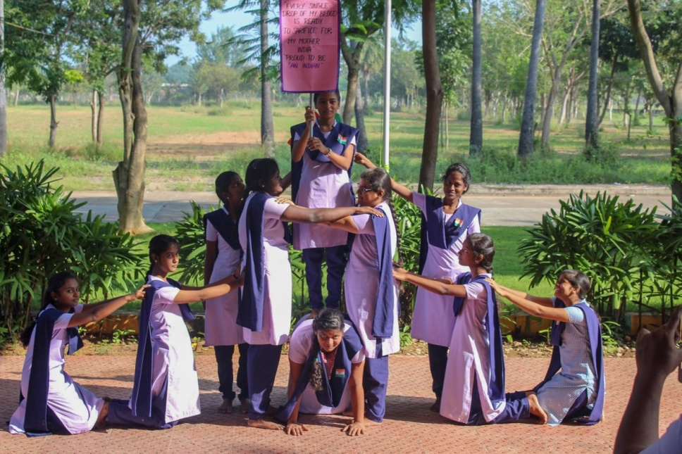

Name of the Programme: 73rd Independence Day
Date: 15.08.2020
Chief Guest: Dr.T.K.Nagarajan M.A,B.Ed,M.Phil,Ph.D , Debate Speaker
Activities: Flag hoisting and speech by Chief Guest
No. of Participants: 100
Photos
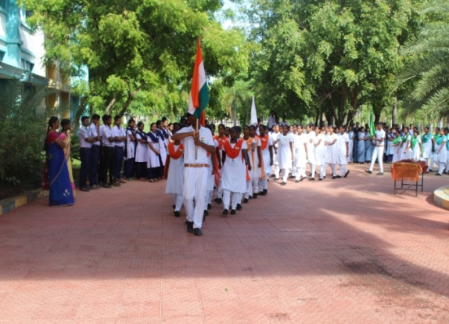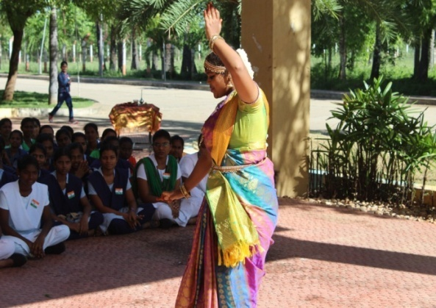

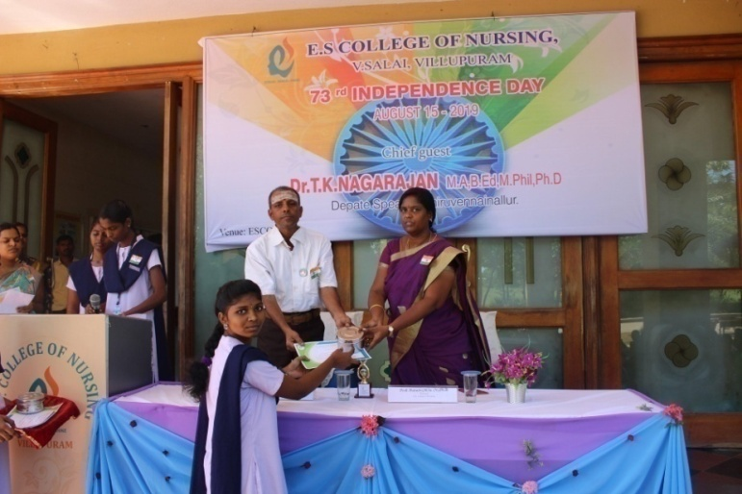

STUDENT NURSES ACTIVITIES 2019-2020
Name of the Programme: 71st Republic Day
Date: 26.01.2020
Chief Guest: Mr. Martin Mangalaraj, Executive director, St.Theresa Skill Development, Villupuram.
Activities: Flag hoisting and Oath taking
No. of Participants: 100
Photos

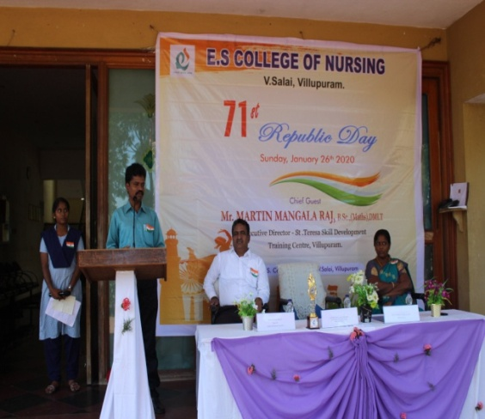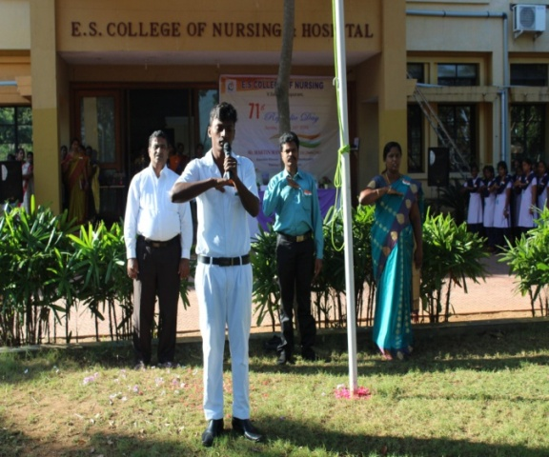

Name of the Programme: Pongal Celebration
Date: 12.01.2020
Activities: Preparing Pongal, Debate
No. of Participants: 300
Photos
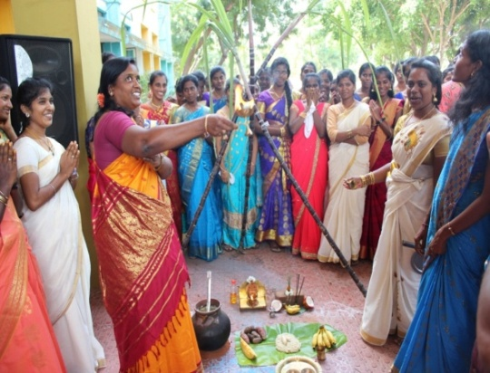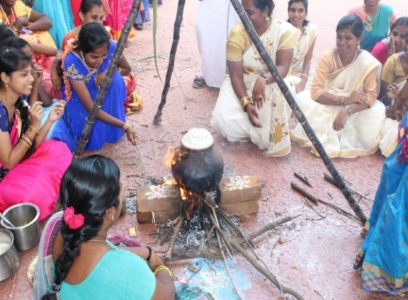

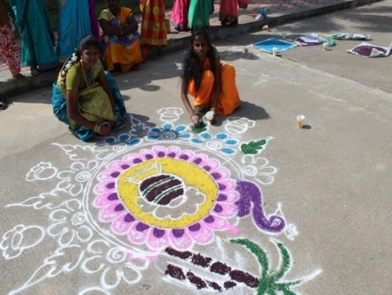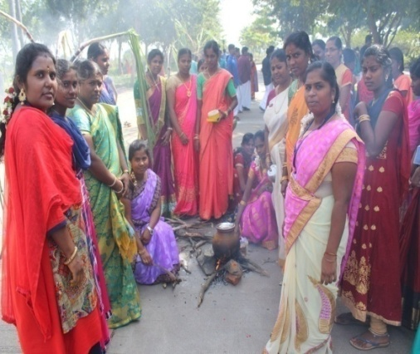

Department/Cell/Club: SNA
Name of the Programme: Freshers’ day
Date: 30.11.2019
Activities: Orientation of Freshers and exhibiting their talents

Photo
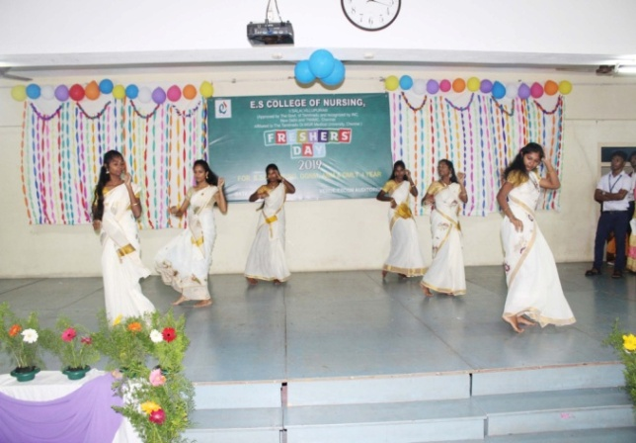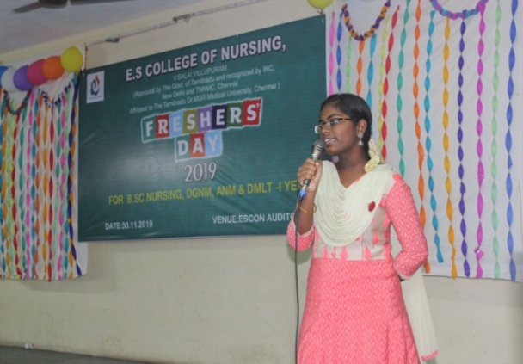
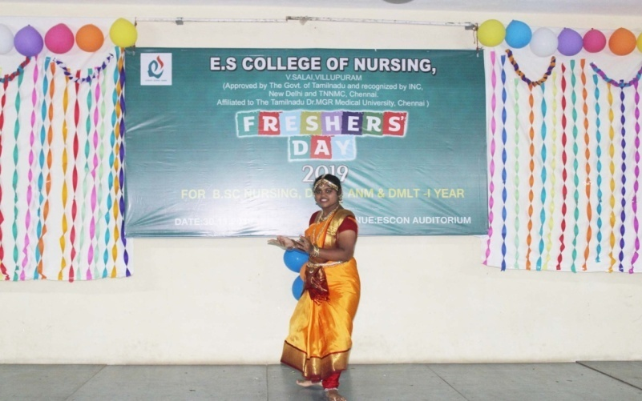

Name of the Programme: World Population Day
Theme: “calls for global attention”
Date: 11.07.2019
Activities: Awareness rally
No. of Beneficiaries: 100
Outcome: Awareness created about impact of population
Photos

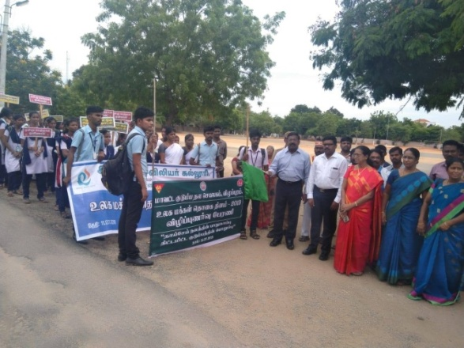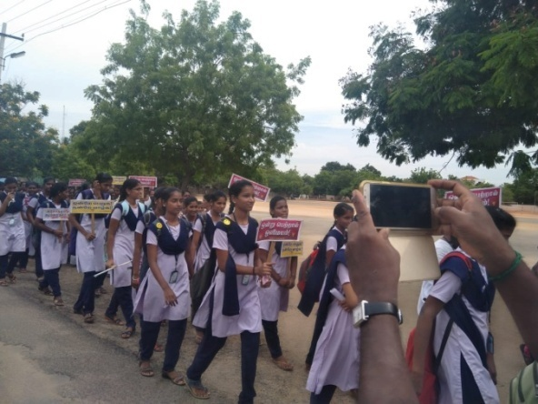

Department/Cell/Club: NSS
Name of the Programme: Training Program-Swachh Bharath mission
Briefing session prior to field activity
Date: 21.06.2019
Activities: Briefing session prior to field activity
No. of Participants: 213
Outcome: Awareness created in relation to ban of use of plastics and saplings planted which creates a remembrance.
Photos
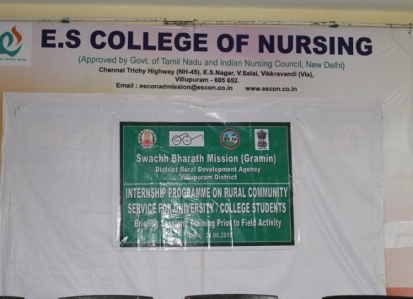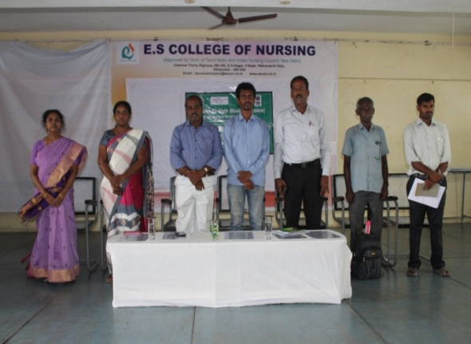
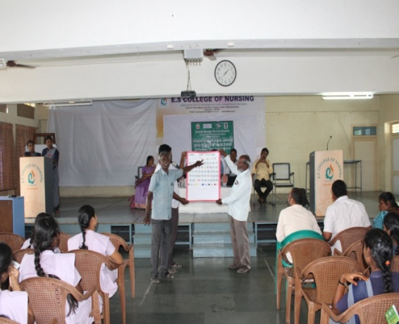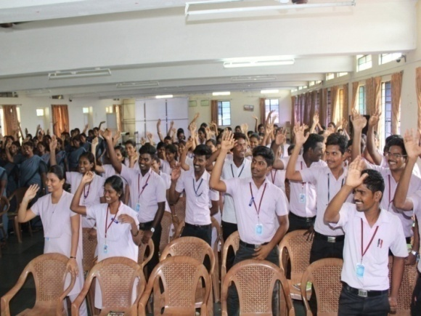

Name of the Programme: World Cancer Day
Theme: “We can I can”.
Date: 09.02.2019
Chief Guest: Dr.L.Subramanian IAS,
Dr.G.Sankaranarayan M.S.,D.L.O.,DNB.,Dean GVMCH.
Activities: Awareness Rally
No. of Beneficiaries: 150
Outcome: Awareness created about early identification & treatment of cancer among public
Photos
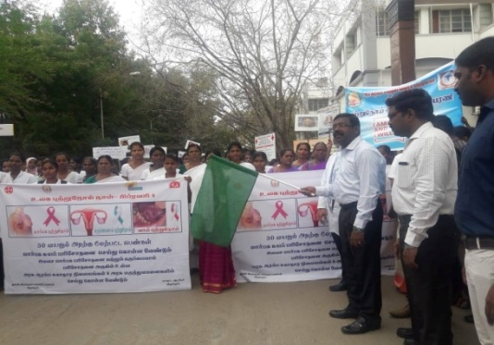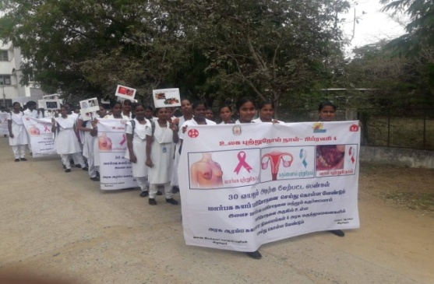
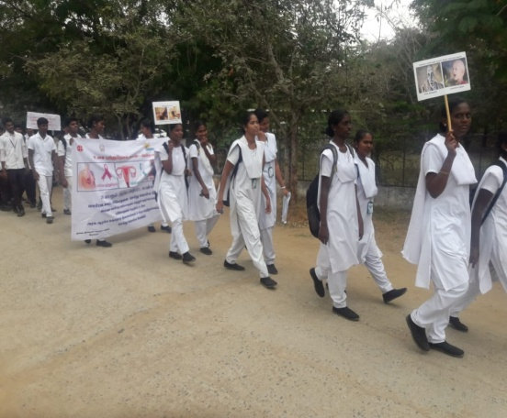

STUDENT NURSES ACTIVITIES 2018-2019

Name of the Programme: Pongal Celebration
Date: 12.01.2019
Activities: Preparing Pongal, Debate
No. of Participants: 300
Photos
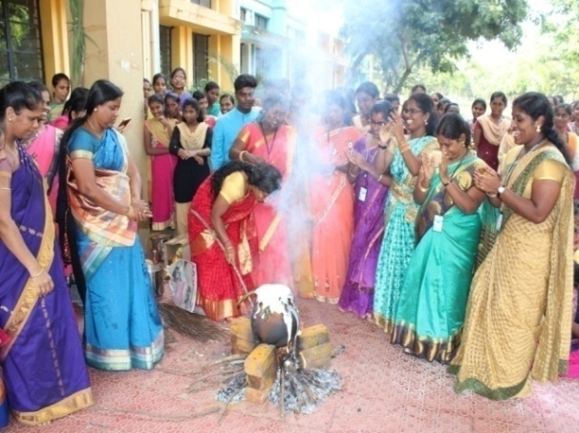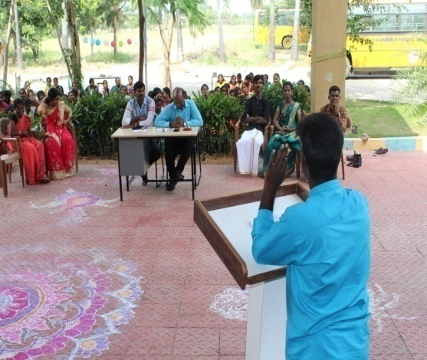

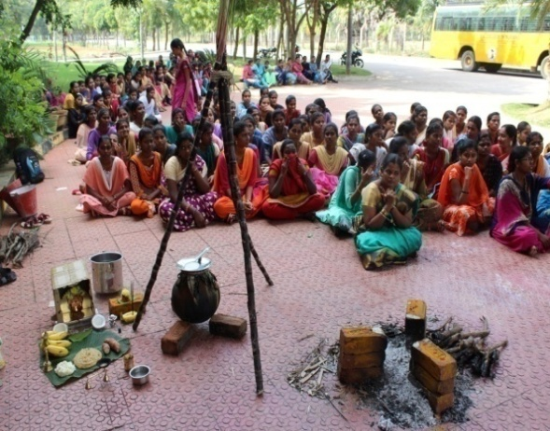

Department/Cell/Club: SNA
Name of the Programme: Hostel day
Date: 14.07.2018
Activities: Celebration with participation of hostelites by participating in dance, fashion show, song and skit.

Photo
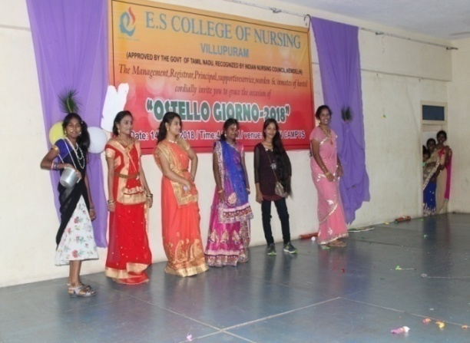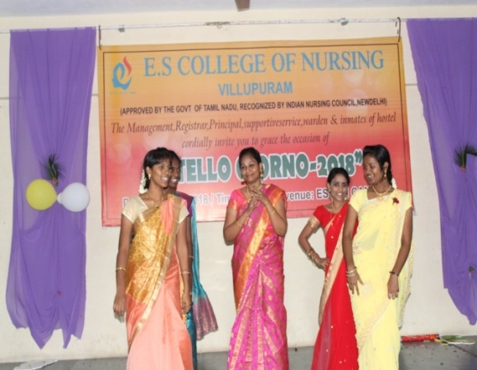

Name of the Programme: World Population Day
Theme: “Family planning is a human right”.
Date: 10.07.2018
Venue: PHC, Radhapuram
Activities: Awareness song and skit related to family planning
No. of Beneficiaries: 100
Outcome: Awareness created about impact of population
Photos
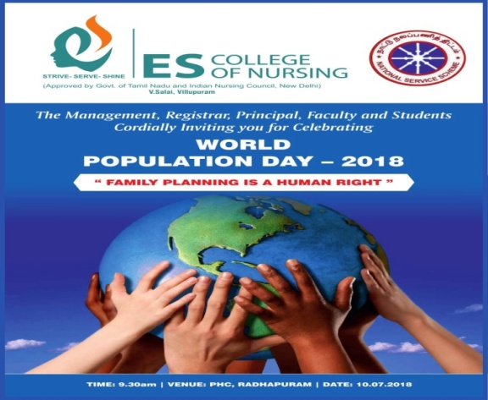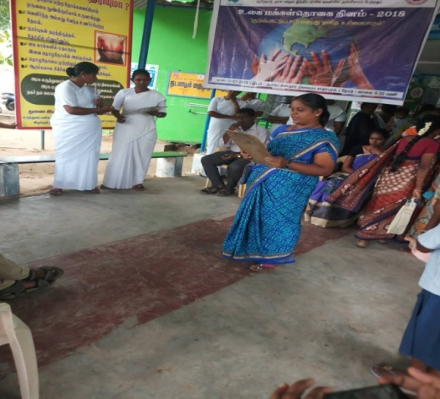

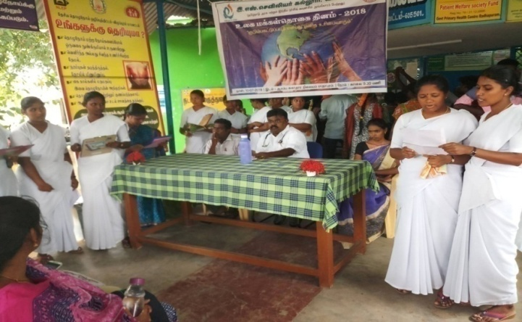

Name of the Programme: International Day of Yoga
Date: 21.06.2018
Chief Guest: Mrs.Ambujam, President “Prajapita Brahma Kumari Ishwariya Vishwa Vidyalaya”
Activities: Chief Guest presented a special session for the students on “IMPROVING SELF CONFIDENCE”. Addition to the highlight of the programme the various yoga techniques & meditation practices was demonstrated.
No. of Beneficiaries: 150
Outcome: Participants did return demonstration on yoga and Meditation Practices.
Photos
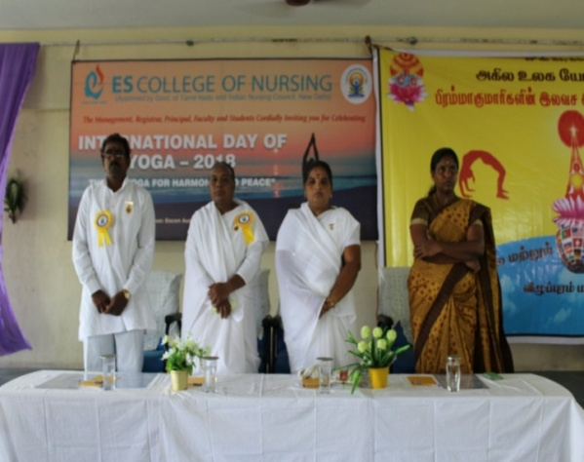
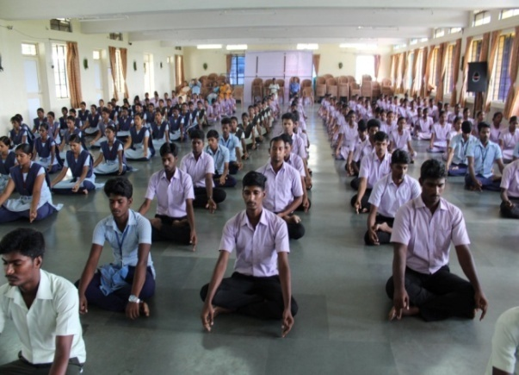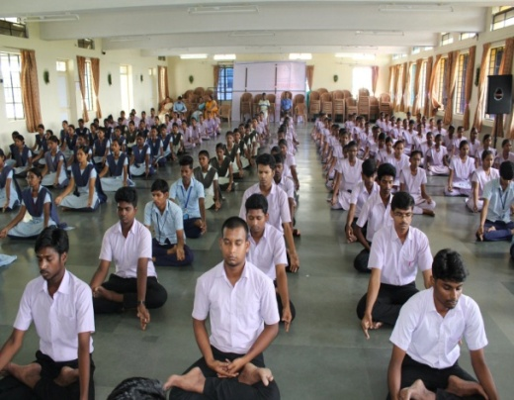

Department/Cell/Club: NSS
Name of the Programme: "World blood donor’s day"
Theme: “BE THERE FOR SOMEONE ELSE. GIVE BLOOD. SHARE LIFE”
Date: 20.06.2018
Chief Guest: Mr.Dhanasekaran, President, Rotary Club, Villupuram
Activities: speech related to theme, blood donation, drawing competition related to theme.
No. of Participants: 120
Outcome: 30 donors including faculty and students donated their blood in this event. Prizes were distributed to winner of drawing competition.
Photos
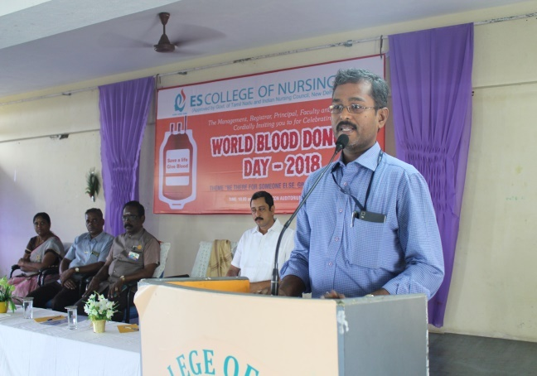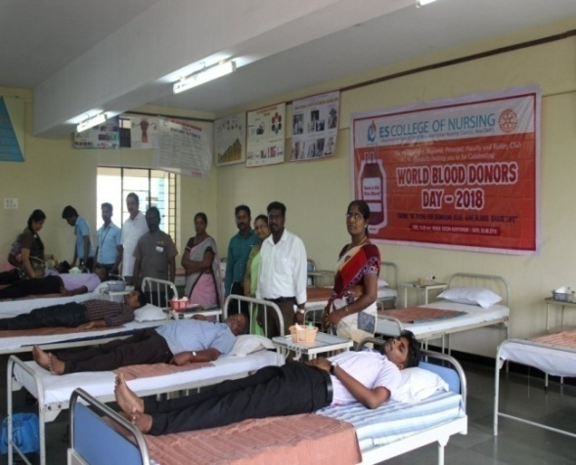
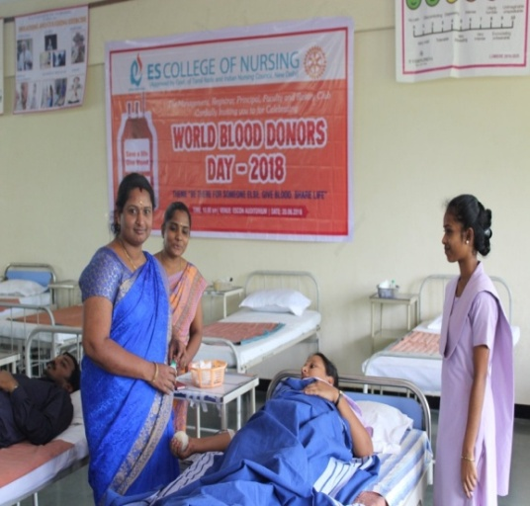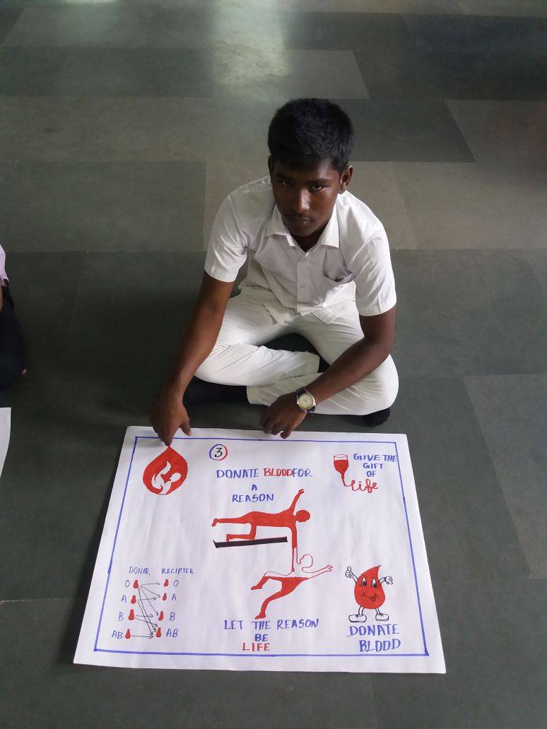

Department/Cell/Club: NSS
Name of the Programme: World Environmental Day
Theme: Plastic Pollution
Date: 05.06.2018
Chief Guest: Mr.Dhanasekaran, President, Rotary Club, Villupuram
Mr.Rajulu, Chairman, TB Awareness Programme
Activities: Theme deliverance speech, oath for not using plastics, and 25 tree saplings planted in the campus.
No. of Participants: 250
Outcome: Awareness created in relation to ban of use of plastics and saplings planted which creates a remembrance.
Photos
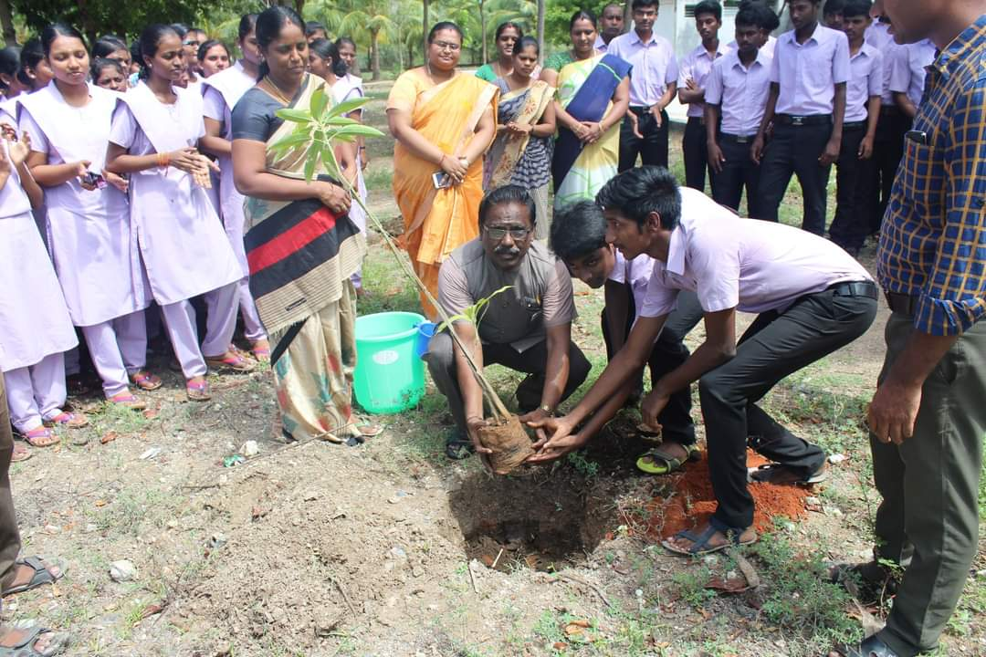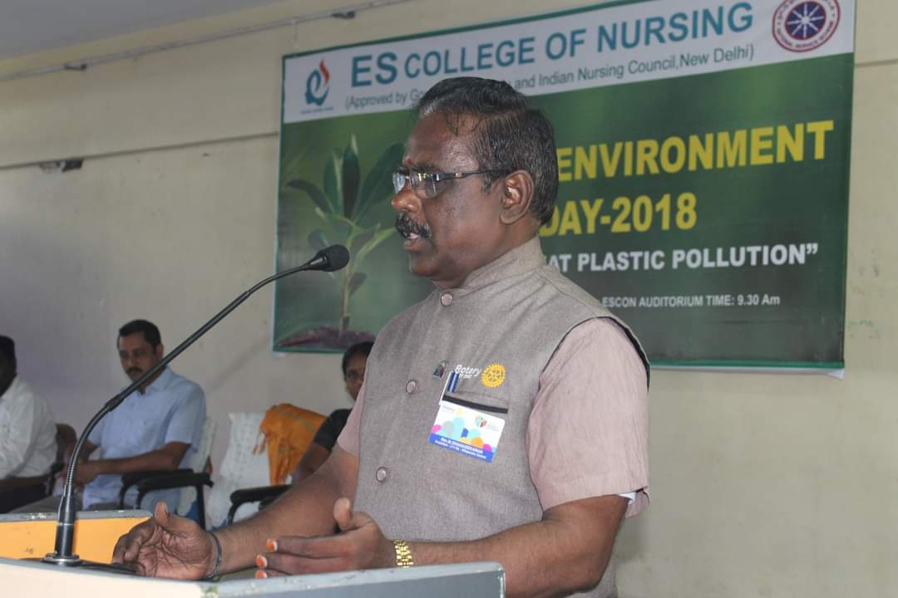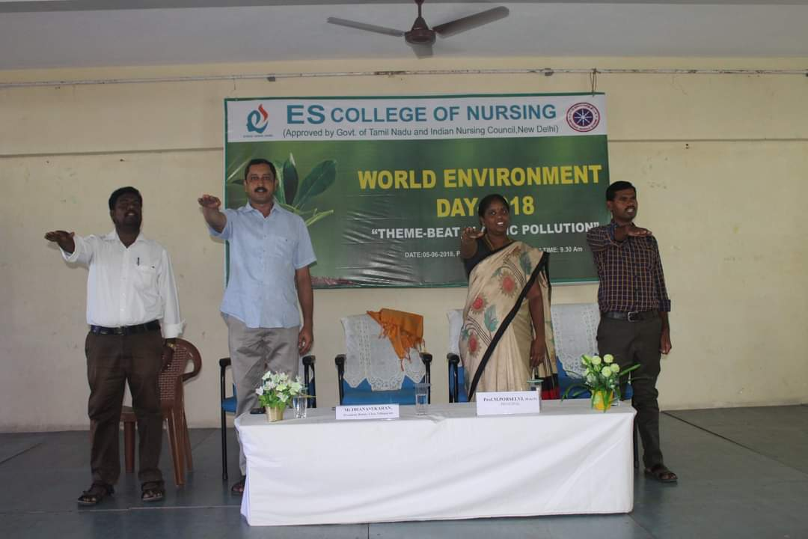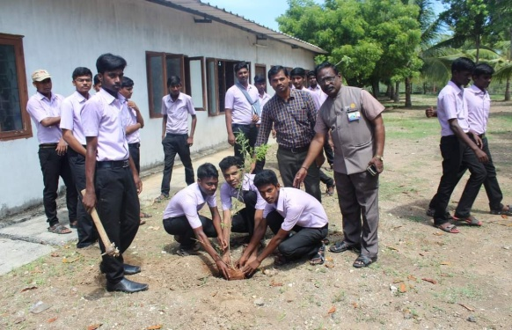

STUDENT NURSES ACTIVITIES 2017-2018
Department/Cell/Club: SNA
Name of the Programme: International Nurses Day
Theme: Nurses: A Voice to Lead-Health is a human right
Date: 12.05.2018
No. of Participants: 350
Photos
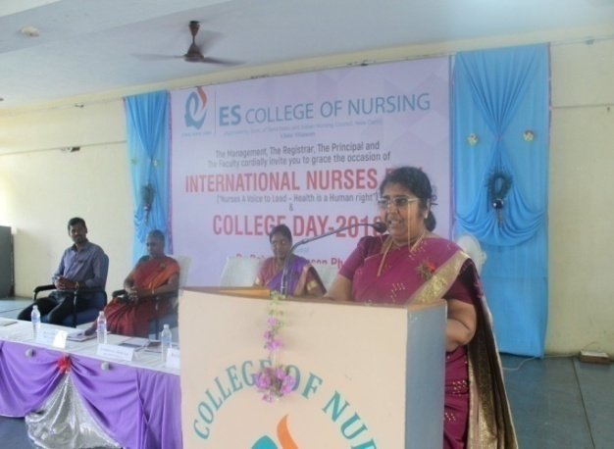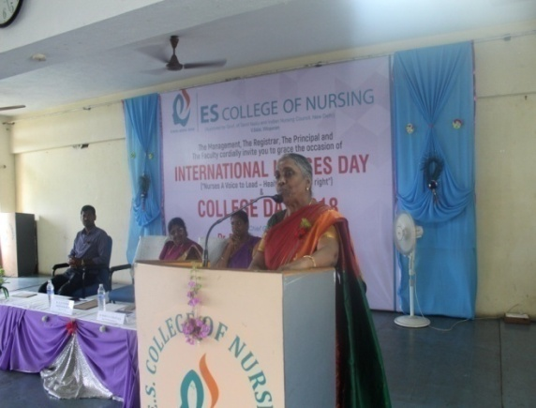

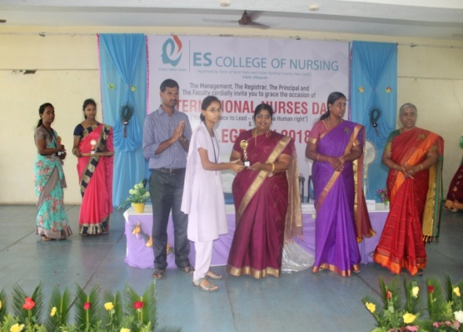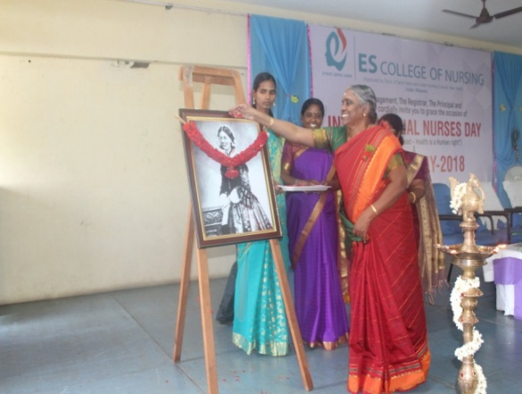

Name of the Programme: 69th Republic Day
Date: 26.01.2018
Chief Guest: Dr.S.Janasakthi Ph.D, Debate Speaker
Activities: Flag hoisting, chief guest address and March
No. of Participants: 100
Photos

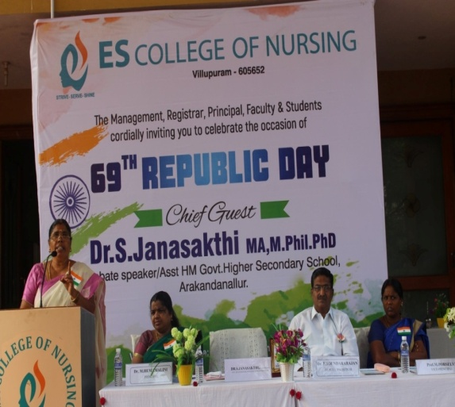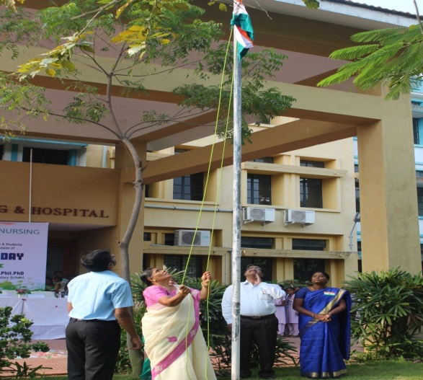

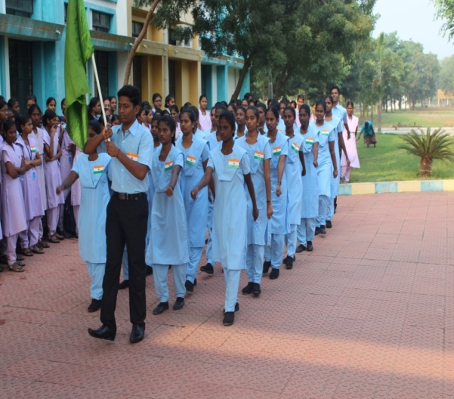

Department/Cell/Club : NSS
Name of the Programme : World Blood Donors Day
Chief Guest : Dr.Subramaniyan, District Collector, Villupuram
Theme : “Give Blood, Give Now, Give Often”
Date : 07.08.2017
Place : District Collectorate Office
No. of Participants
Students : 216
Teachers : 8
No of Beneficiaries : 400
Activities : Students actively participated in Rally and created awareness to the public. They carried placards contains slogans of importance of Blood donation and responsibilities of blood donation as a citizen in the society.
Photo
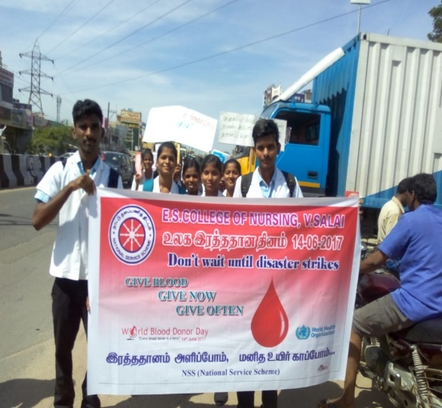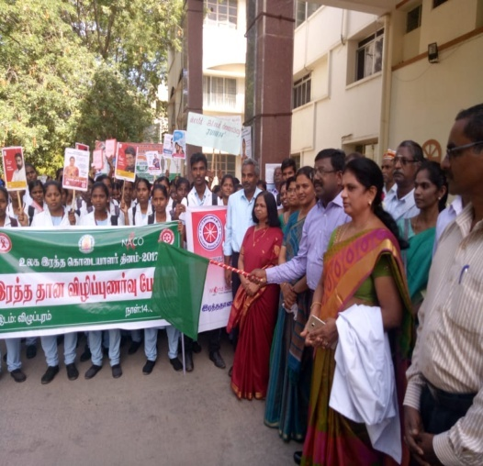
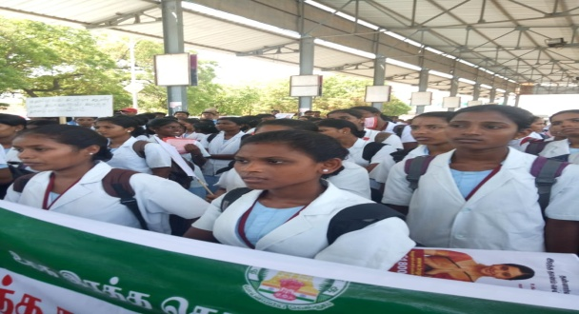

Name of the program : Thanksgiving
Organized by : ‘Abhara Fiesta
Year : 2017
Presidential address was given by : Mrs.HemaMalini, principal
Venue : ESCON

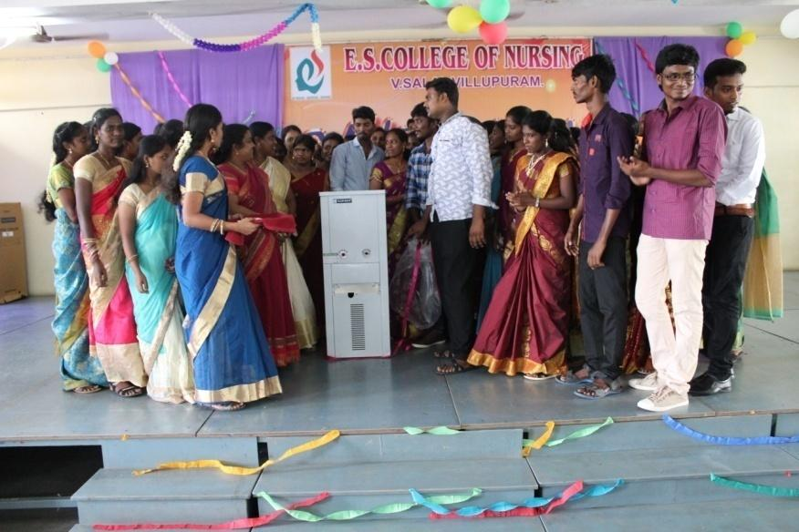

STUDENT NURSES ACTIVITIES 2016-2017
Name of the program : Lamp Lighting Ceremony
Organized by : SNA
Date : 26.11.2016
Presidential address was given by : Mrs.HemaMalini, principal
Venue : ESCON
Chief Guest : Dr.S.D. Manoranjitham SathiyaseelanPh.D Registrar & HOD Psychiatric Nursing department CMC Vellore presided as chief guest.

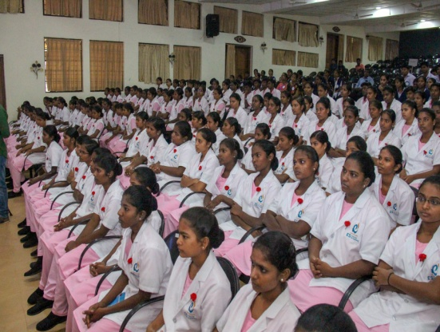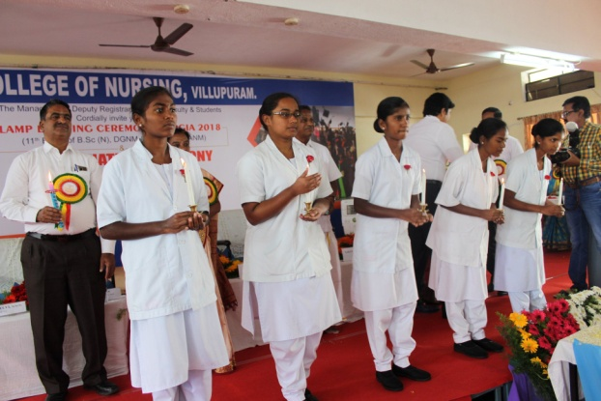

Name of the program : Cultural and sports meet VERVE
Organized by : SNA
Date : 08.05.2017
Venue : ESCON
Chief Guest : .Mrs.Porselvi, Vice Principal

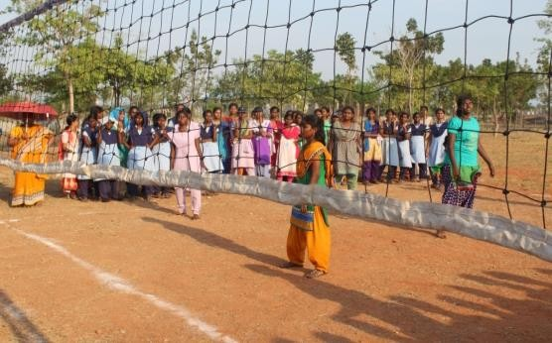
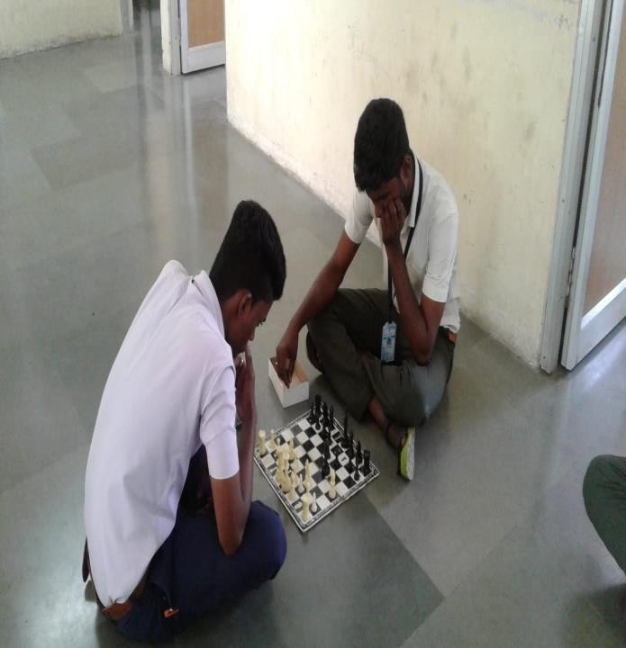
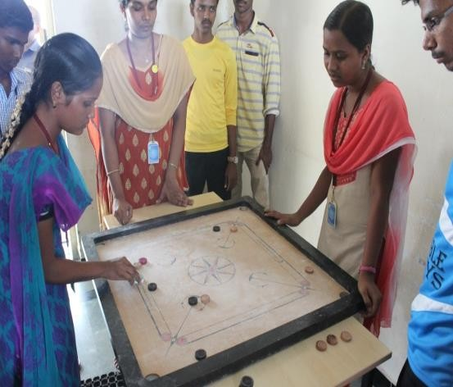

Name of the program : Nurses Day Celebration
Organized by : SNA
Date : 12.05.2017
Venue : ESCON
Chief Guest : Chief Guest Dr.Vanithamani M.B.B.S., M.S (CTS) Dean

